**Topics: Descriptive Statistics and Probability**

1. Look at the data given below. Plot the data, find the outliers and find out $μ, σ, σ^{2}$

|  |  |
| --- | --- |
| **Name of company** | **Measure X** |
| Allied Signal | 24.23% |
| Bankers Trust | 25.53% |
| General Mills | 25.41% |
| ITT Industries | 24.14% |
| J.P.Morgan & Co. | 29.62% |
| Lehman Brothers | 28.25% |
| Marriott | 25.81% |
| MCI | 24.39% |
| Merrill Lynch | 40.26% |
| Microsoft | 32.95% |
| Morgan Stanley | 91.36% |
| Sun Microsystems | 25.99% |
| Travelers | 39.42% |
| US Airways | 26.71% |
| Warner-Lambert | 35.00% |

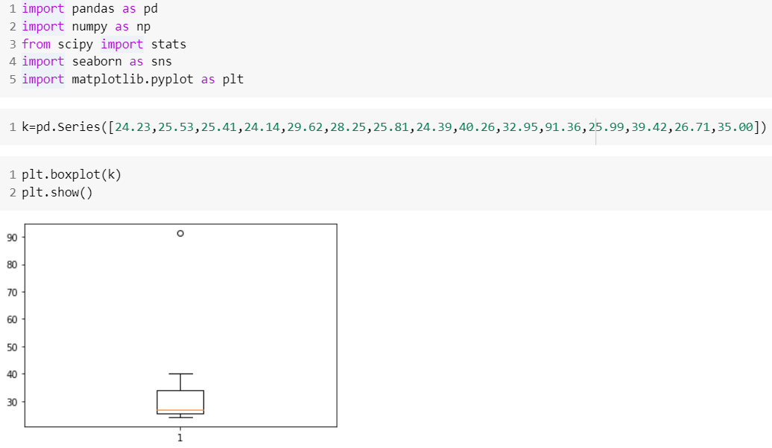

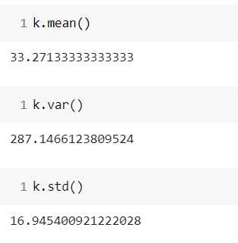



Answer the following three questions based on the box-plot above.

1. What is inter-quartile range of this dataset? (please approximate the numbers) In one line, explain what this value implies.

Approximately Q1 = 5 , (Third Quartile Range) Q3 = 12,

Median (Second Quartile Range) = 7 (Inter-Quartile Range) IQR = Q3 – Q1 = 12 – 5 = 7 Second Quartile Range is the Median Value

1. What can we say about the skewness of this dataset?

Data is right skewed

1. If it was found that the data point with the value 25 is actually 2.5, how would the new box-plot be affected?

No outliers available. Graph will move towards Normal distributions



Answer the following three questions based on the histogram above.

1. Where would the mode of this dataset lie?

Will lie in between 5 to 6

1. Comment on the skewness of the dataset.

Right Skewed

1. Suppose that the above histogram and the box-plot in question 2 are plotted for the same dataset. Explain how these graphs complement each other in providing information about any dataset.

Both data set are right skewed. Common outlier is 25

1. AT&T was running commercials in 1990 aimed at luring back customers who had switched to one of the other long-distance phone service providers. One such commercial shows a businessman trying to reach Phoenix and mistakenly getting Fiji, where a half-naked native on a beach responds incomprehensibly in Polynesian. When asked about this advertisement, AT&T admitted that the portrayed incident did not actually take place but added that this was an enactment of something that “could happen.” Suppose that one in 200 long-distance telephone calls is misdirected. What is the probability that at least one in five attempted telephone calls reaches the wrong number? (Assume independence of attempts.)

Probability of misdirection Not success =1/200

Probability of not misdirect Success =199/200

No of calls 5

These are mutually in depended events

At least one call in 5 attempts reached to wrong no is

=1 – probability of success

=1- ⁿCpˣqⁿ⁻ˣ

=1- 5C(1/200)(199/200) ^ 5

=1-(199/200)^5

=0.024

1. Returns on a certain business venture, to the nearest $1,000, are known to follow the following probability distribution

|  |  |
| --- | --- |
| x | P(x) |
| -2,000 | 0.1 |
| -1,000 | 0.1 |
| 0 | 0.2 |
| 1000 | 0.2 |
| 2000 | 0.3 |
| 3000 | 0.1 |

1. What is the most likely monetary outcome of the business venture?

Most likely outcome is =0.3 at value 2000

1. Is the venture likely to be successful? Explain

probability sum for 0 to positive are 0.2 ,0.2 ,0.3 and 0.1 which is 0.8. So 80 % chance for profit

1. What is the long-term average earning of business ventures of this kind? Explain

For average of probability we need get average by multiply x by probity of x which is 800 $

1. What is the good measure of the risk involved in a venture of this kind? Compute this measure

If graph of variance is having large spread the risk will be more as chances of having points at tail will be more In this case STD deviation for x is 1870